Smart Farming Application

Category: Internet of Things

Industry Mentors:

* Sowjanya
* Sandeep

Faculty Mentor:

G. Monisha

Team Leader:

V.Priya

Team Members:

* X. Sneha
* R. Sandhiya
* M. Navaniya shanmugabharathi

Use cases:-

* Data collection:-

Smart farming sensor can monitor weather condition, soil quality, crop growth progress.

* Cost management:-

Scientifically knowing how much water a plat needs for growth, versus the actual amount that it’s fed, will educate farmers to cut down unnecessary irrigation ant to conserve water.

* Enhanced product quality:-

Quality control is already an aspect of IOT in manufacturing, wherein thermal, and other related sensors are able to constantly monitor the quality metrics of produced goods.

Novelty:-

* **Adoption of internet connectivity solutions in farming practices has been triggered, to reduce the need for manual labor.**
* **Enables growers and farmers to reduce waste and enhance productivity.**
* **Focused on helping farmers close the supply demand gap.**

**Feasability of idea:-**

* The approach of using IOT technology to ensure optimum application of resources to achieve high crop yields and reduce operational costs is called precision agriculture.
* The farmers can monitor the field conditions from anywhere.

Business model:-

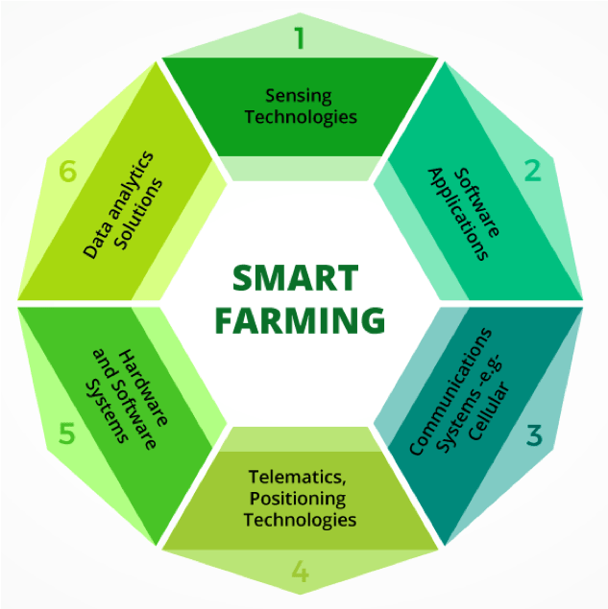

Social Impact:-

With IOT, companies can enjoy benefits like **better crop productivity and improved worker safety**. They can use less fertilizer, water and pesticides. Because farmers can decrease the fertilizers and pesticides they use, there is less runoff into groundwater and rivers. This results in a lower impact on the ecosystem.

Scalability of solution:-

* Automatic adjustment of farming equipment made possible by linking information like crops/weather and equipment to auto-adjust temperature, humidity, etc.
* In large farmland, Internet of Things equipped drone helps to receive the current state of crops and send the live pictures of farmland.
* Analyzing farmland from the land using its Solutions you will know the current situation of fields and crops in.